UC Merced Statistics
Accolades
According to U.S. News and World Report, UC Merced is ranked #97 in National Universities, #171 in Best Value Schools, #5 in Top Performers on Social Mobility, #40 in Top Public Schools, and #145 in Best Undergraduate Engineering Programs. For additional accolades, please consult https://www.ucmerced.edu/accolades.

Milestones
- 1988 – Authorized by California legislature
- 1995 – The Merced site was chosen for the newest UC campus.
- 2003 – Faculty members began to arrive and set up research laboratories and programs
- 2004 – Opened for graduate students
- 2005 – Opened for undergraduate students
- 2020 – The $1.3 billion Merced 2020 Project, a public-private partnership to expand teaching, research, residential, athletic, and retail space on campus was completed

Growth in Research Expenditures Over Time
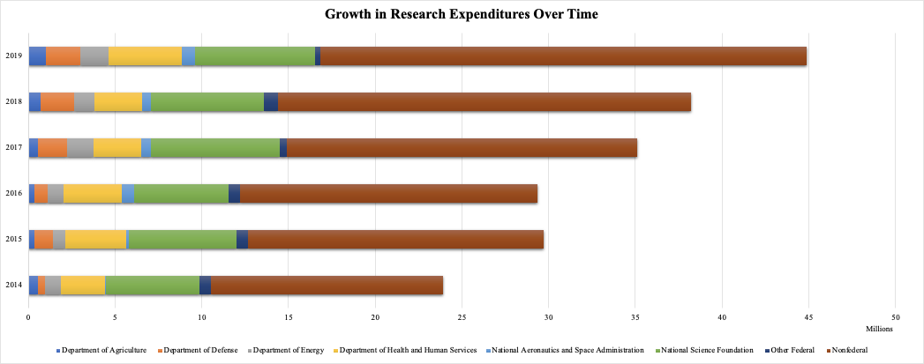
*Source: National Center for Science and Engineering Statistics, Higher Education Research and Development Survey.

Federal Awards by Agency (2020-2021)
Agency | Amount
Department of Agriculture (USDA) | $1,047K
Department of Commerce | $74K
Department of Defense (DOD) | $1,729K
Department of Education (ED) | $27,637K
Department of Energy (DOE) | $1,172K
Department of Health and Human Services (HHS) | $2,707K
Department of the Interior | $414K
National Aeronautics and Space Administration (NASA) | $913K
National Science Foundation (NSF) | $7,464K
Total | $43,158K

Students by Class Level (Fall 2020)
Level | Number | Percent
Undergraduate | 8,276 | 92%
Graduate | 742 | 8%
Total | 9,018 | 100%

Faculty Composition by School (Fall 2020)
School | Number | Percent
Engineering | 77 | 23.2%
Natural Sciences | 96 | 28.9%
Social Sciences, Humanities and Arts | 159 | 47.9%
Total | 332 | 100%

