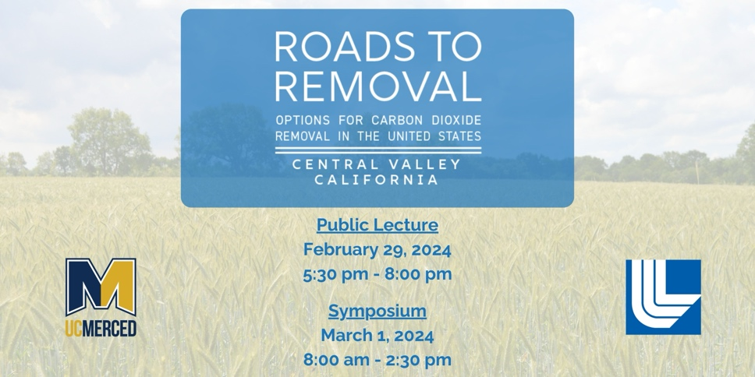

You’re Invited to the Roads to Removal Central Valley Public Lecture & Symposium
February 29 (Public Lecture) and March 1 (Symposium)
Join UC Merced, Lawrence Livermore National Laboratory, and Roads to Removal report authors, for a public lecture and in-person symposium examining the options, benefits, tradeoffs and costs of carbon dioxide (CO₂) removal in California.
What are the opportunities for carbon dioxide removal (CO₂) in California's Central Valley?
How can soil and cropland management as well as biomass investments play significant roles?
Where are the best locations for projects and geological storage?
What economic and community considerations are paramount?
Can the United States meet carbon dioxide emission goals (net zero) by 2050?
The Roads to Removal report, commissioned by the Department of Energy, is a comprehensive, region-by-region analysis of the potential for CO₂ removal methods across the United States. The report provides interactive county-level data with specific recommendations on cropland and soils practices, forest management, biomass carbon removal and storage (BiCRS), direct air capture (DAC), transportation and storage opportunities. Also included: workforce development, energy, environmental, community and equity considerations. This two-day event is designed to help local leaders make informed decisions. The Central Valley has a number of significant carbon dioxide removal opportunities that can be implemented immediately.
Don’t miss out on this important regional conversation–register today!
The two-day Roads to Removal event is free and open to the public.
Seating is limited–early registration encouraged.

CLICK HERE TO REGISTER

